# Week #6

**Designing and Simulation of Network Topology using Cisco Packet Tracer**

**SRN : PES2UG20CS237**

**Name : P K Navin Shrinivas**

**Section : D**

## Task 1 (Demo) Network Topology:

To replicate given scenario, create a topology in packet tracer, as shown in following image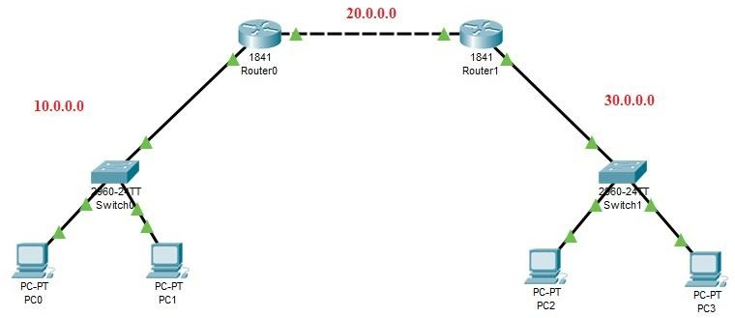.

**Configuration followed :**

**PC5:**

**PC6:**

IP Address ---> 192.168.1.10

Gateway ---> 192.168.1.1

IP Address ---> 192.168.1.11

Gateway ---> 192.168.1.1

## Router 4:

FastEthernet0/0 ---> 192.168.1.1

FastEthernet0/1 ---> 10.0.4.1

## Router 5:

FastEthernet0/0 ---> 10.0.4.2

FastEthernet0/1 ---> 192.168.2.1

## PC7:

**PC8:**

IP Address ---> 192.168.2.10

Gateway ---> 192.168.2.1

IP Address ---> 192.168.2.11

Gateway ---> 192.168.2.1

## Routing Table Entries:

|  |  |  |
| --- | --- | --- |
| **Router** | **Network** | **Next Hop** |
| Router 4 | **192.168.2.0** | **10.0.4.2** |
| Router 5 | **192.168.1.0** | **10.0.4.1** |

**Execution Procedure:**

**Task 1:** Design a network topology with desktops, switches and routers similar to the network depicted in the above diagram.

**Task 2:** Configure the PCs and routers with the details provided above.

**Task 3:** Send a simple PDU from any PC on network 10.0.1.0 to any other PC on other network

10.0.3.0 and vice-versa.

**Task 4:** Simulate the network and observe the packet flow from one network to other.

**Screenshot :**

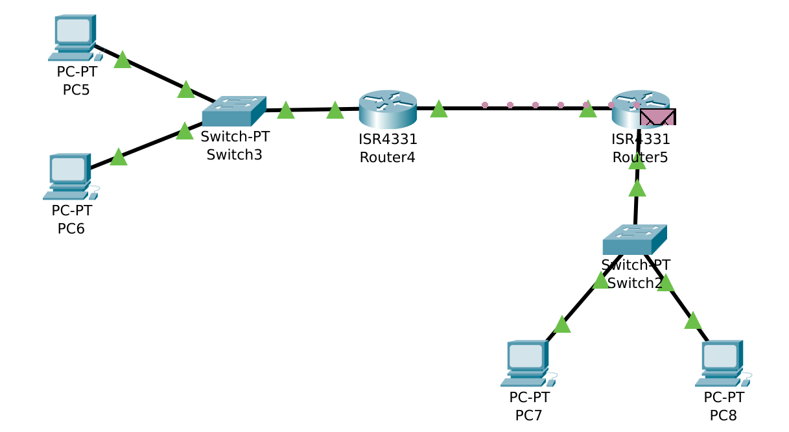

## **Task 2 (Mandatory for Week-6****)**

## **My implmentation :**

## 